Date: February 6, 2018 #18-033
District: District 3 - Marysville, www.dot.ca.gov/dist3
Contact: Dennis Keaton dennis.keaton@dot.ca.gov
Phone: (530) 741-5474

District: District 4 - Oakland
Contact: Vince Jacala vince.jacala@dot.ca.gov
Phone: (510) 286-5206

District: District 10 - Stockton
Contact: Skip Allum skip.allum@dot.ca.gov
Phone: (209) 948-7176

FOR IMMEDIATE RELEASE

Update: Highway 12 - Rio Vista Bridge Paint Project Begins Feb. 15
Nightly One-Way Traffic Controls Scheduled Expect Delays

SACRAMENTO and SOLANO COUNTIES – Caltrans is alerting motorists that overnight lane closures on the State Highway 12 Rio Vista Bridge in the Delta are scheduled to begin on Thursday, February 15.

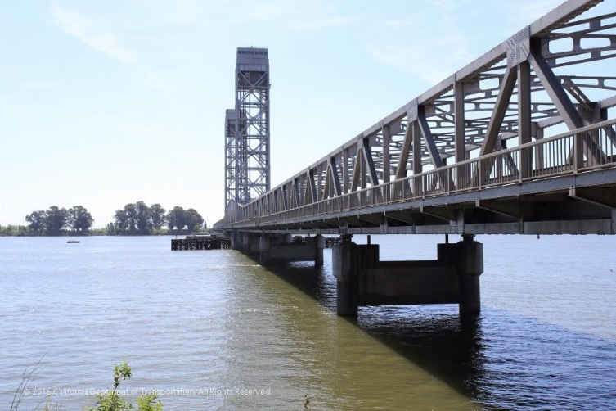
Motorists should allow additional travel time in the area as crews begin work on a $37.1 million painting project aimed at preserving the structure over the Sacramento River in Sacramento and Solano counties.

The drawbridge will remain open to traffic throughout the project. However, one of the two lanes on the bridge will be closed during the overnight hours on weekdays and some weekends to accommodate crews. Bicycle and pedestrian access will remain open. Motorists can expect delays because of the one-way traffic controls.

The project is lengthy because there will be no complete closures of the bridge and work will be limited to nighttime into the early morning during the week with some weekends as needed. Completion is expected by winter 2020.

Daily Schedule
7 p.m. to 6 a.m. Monday through Thursday and 8 p.m. to 9 a.m. Friday. The weekend schedule (as needed) is 7 p.m. to 10 a.m. Saturday and 7 p.m. to 6 a.m. Sunday.

One-Way Traffic Controls
Even though no full-highway closures are scheduled, motorists will experience delays as crews work. Intermittent one-way traffic control with flaggers will be in effect.

During the one-way traffic controls, crews will alternate traffic in the eastbound and westbound directions on the bridge. This will allow one lane on the bridge to remain open during the work.

The California Highway Patrol will be at the worksite enforcing the traffic management by Caltrans. First responder vehicles on emergency calls will have priority access.

Boat and Ship Traffic
For mariner traffic, the bridge will open only during specified times or in a maritime emergency. Ship captains and boaters must contact the U. S. Coast Guard District 11 for additional information at 510-437-3516 or visit http://www.pacificarea.uscg.mil/Our-Organization/District-11/ or http://www.navcen.uscg.gov/?pageName=lnmDistrict®ion=11

Caltrans urges all motorists to do advanced planning before traveling by accessing the Caltrans public website at http://www.dot.ca.gov/d3/ for planned weekly roadwork schedules that may include detours and to use an alternate route, expect additional travel times and/or delays.

Weather or unexpected events may delay or prolong the work. Caltrans advises motorists to “Be Work Zone Alert.” The department will issue construction updates on Twitter @CaltransDist3 and on Facebook at CaltransDistrict3. For real-time traffic information, click on Caltrans’ QuickMap quickmap.dot.ca.gov/ or download the QuickMap app on iTunes or Google Play.

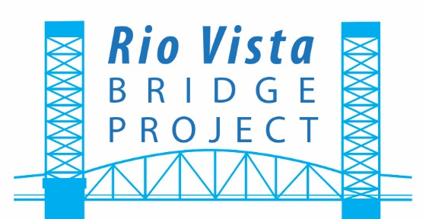

##

Map not to scale.




